

Refund and ChargeBack- Lot 2

SYSTEM DESIGN DOCUMENT

Version 1.0

Confidentiality Statement

**This document contains information that is proprietary and confidential to Tata Consultancy Services Limited, which shall not be disclosed outside Transport for London, transmitted, or duplicated, used in whole or in part for any purpose other than its intended purpose. Any use or disclosure in whole or in part of this information without express written permission of Tata Consultancy Services is prohibited. Any other company and product names mentioned are used for identification purposes only and may be trademarks of their respective owners.**

**© Copyright <2021>, Tata Consultancy Services (TCS)**

TATA Code of Conduct

**We, in our dealings, are self-regulated by a code of conduct as enshrined in the ‘TATA Code of Conduct’. We request your support in helping us adhere to the code in letter and spirit. We request that any violation or potential violation of the code by any person be promptly brought to the notice of the Local Ethics Counsellor or the Principal Ethics Counsellors or the CEO of TCS. All communication received in this regard will be treated and kept as confidential.**

**Table 1: DOCUMENT REVISION LIST**

|  |  |  |  |
| --- | --- | --- | --- |
| Revision No. | Revision Date | Author | Revision Description |
| 1.0 | 19-Nov-2021 | Pranav Gandhi | This document covers Refund and Chargeback process Initiated and processed by TFL Users. |

Contents

1 Introduction 7

1.1 Purpose 7

1.2 List of Abbreviations 7

1.3 Audience 8

2 Process Description 9

2.1 Chargeback 10

2.1.1 Pre-Requisite 10

2.1.2 Business Process Map 10

2.1.3 Form Specifications 11

2.1.4 Notifications 14

2.1.5 Validations & Business Rules 15

2.1.6 Outcome of the Process 15

List of Figures

Figure 3: Process Map of Chargeback 10

List of Tables

Table 1: DOCUMENT REVISION LIST 3

Table 2: List of Abbreviations 7

Table 3: Process and Sub-process List 9

Table 4:Form Specification: Initiate Chargeback Request 11

Table 5- Alert and Notifications – Initiate Refund Screen 12

Table 6: Form Specification: Review Chargeback Recommendation 12

Table 7- Alert and Notifications – Initiate Refund Screen 14

Table 8: Notifications 14

Table 9: Business Rules and Validation 15

# Introduction

## Purpose

The objective of this document is to outline design for Chargeback process that will be initiated from Back Office Portal and checked by Lot 2 User in backoffice portal. This document specifies Pre-Requisites, Business Process Maps associated with process, Form Specifications, Actions and Stakeholder details, Business Rules and Validations, Alerts and Notification, and Integration. Following are the list of Process/ Subprocesses which are covered under this document.

* Review Chargeback Request

## List of Abbreviations

**Table 2: List of Abbreviations**

|  |  |
| --- | --- |
| Abbreviation | Expanded Form |
| TfL | Transport for London |
| TCS | Tata Consultancy Services Ltd. |
| TPH | Taxi and Private Hire |
| PHV | Private Hire Vehicle |

## Audience

This document is intended to provide an understanding on business functions to different teams:

* TfL Project Management
* TfL SMEs
* TCS Project team for Designing Payment Process
* Lot 2 Supplier

# Process Description

The Chargeback process is initiated by the user through the bank. Once the chargeback request is received by TFL, the customer will be able to view the status of the chargeback request. TFL shall process the chargeback request and if approved the charges shall be credited to the requested bank. However, there can be a case that the payment becomes due post chargeback and the user needs to pay to complete an application. If the chargeback is received post issuance of a licence then the post licensing action of suspension may be initiated by TFL.

**Table 3: Process and Sub-process List**

|  |  |  |  |  |
| --- | --- | --- | --- | --- |
| **Process** | | **Application** | | **Description** |
| 3 | Chargeback | Review Chargeback request | Online | The TFL user will be able to review and approve/reject the request received from the bank. |

## Chargeback

This Process will be initiated from Customers to their respective banks. Bank will raise a Chargeback request with TfL. TfL will receive request from bank, create a workflow request and send the same to Lot 2 for review process. Lot 2 will review the request and provide the recommendation for approval or rejection of Chargeback. TfL user will then take decision to approve/ reject the Chargeback. If Chargeback is approved, the process will be closed, and customer will be notified. If Chargeback is rejected, then the amount will be converted to debt for customer and customer will be asked to make payment. If Customer make payment, then Chargeback process will be closed and if customer does not make payment then process for Revocation/ Suspension of licence will be initiated.

### Pre-Requisite

* CSR should have authorisation to create workflow for Chargeback request.

### Business Process Map

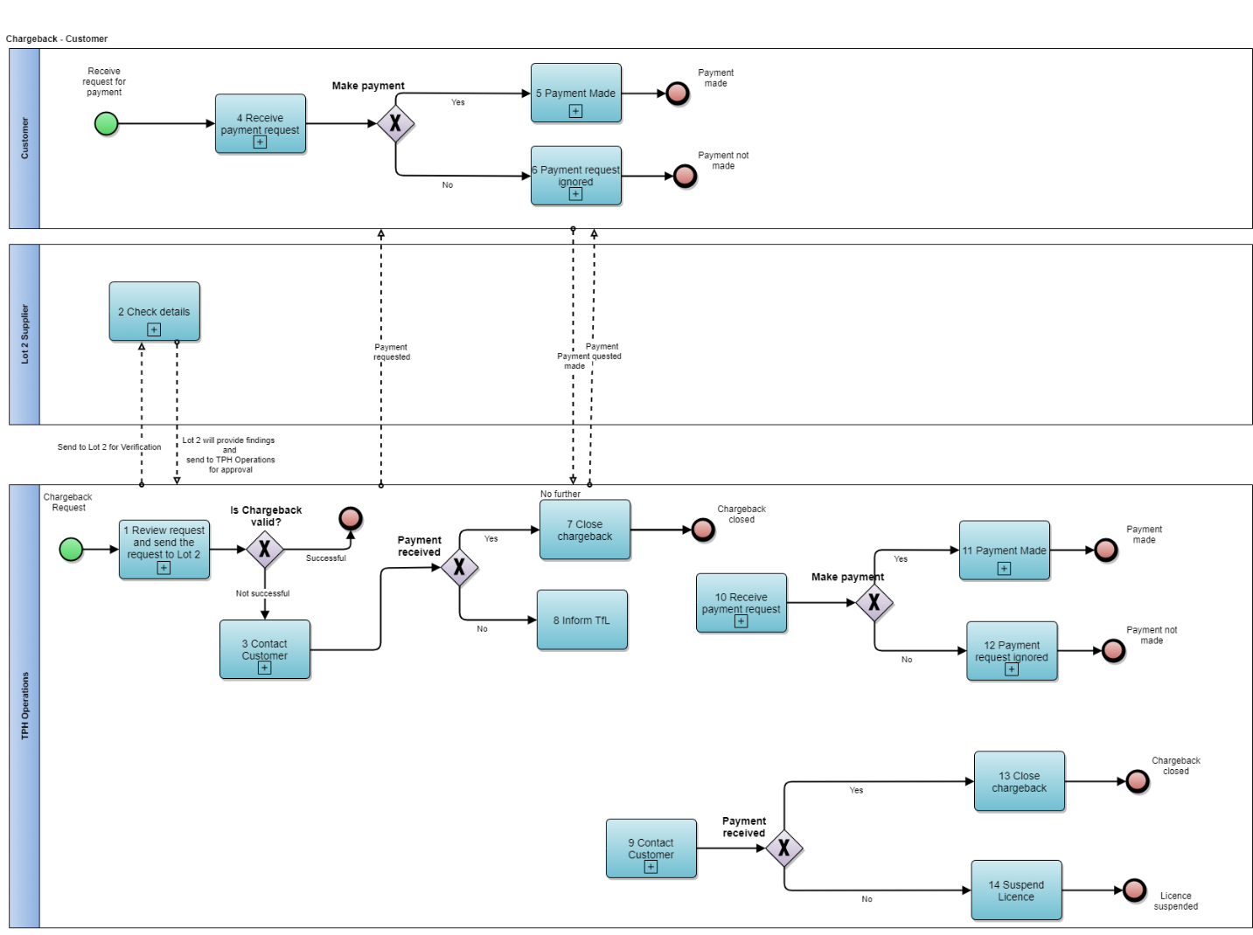

**Figure 3: Process Map of Chargeback**

**Process Flow Description: Raise Request (Online)**

* Customer will request the Chargeback from the bank and bank will credit the amount to customer of Chargeback request
* Bank will then send request of Chargeback to TfL then Chargeback will be processed as the following
  1. TPH Operations Team will receive the request for Chargeback. After initial review the request will be sent to Lot 2 supplier for verification purpose.
  2. Lot 2 team will check the customer details like payment details, licence details etc.
  3. Then, the request will be forwarded to TPH operations for further actions.
  4. If Chargeback is valid then process will be ended. If Chargeback is not valid then debt will be created for customer then, TPH user will contact customer and request for payment as the original amount paid was refunded by bank to customer. Customer will receive notification via PMOC to make payment.
  5. If customer, agrees to pay then payment will be recorded against customer and debt will be removed.
  6. If customer ignores payment request then, (14) Licence suspension and revocation process will be triggered
  7. If customer agrees to pay then, Chargeback will be closed, and customer will be notified for the same.

### Form Specifications

#### Form: Initiate Chargeback Request

Lot 2 will review Chargeback request from TfL and perform various search operations and provide additional details and recommendation to TfL.

**Table 4:Form Specification: Initiate Chargeback Request**

|  |  |  |  |  |  |  |
| --- | --- | --- | --- | --- | --- | --- |
| **Sub-Section** | **Field Name** | **Field Type** | **Field Length** | **Description** | **M/O/C/A** | **Remarks** |
| ***Record Licence Details*** | Transaction Number | Textbox | 100 | Denotes transaction number (Original transaction) for which Chargeback is processed by banks | A |  |
| Transaction Date | Datebox |  |  | A |  |
| Bank Reference Number | Textbox | 100 | Denotes reference number generated from the bank for original transaction | A |  |
| Chargeback Amount | Decimal |  | Amount processed by bank as a Chargeback | A |  |
| Customer Reference Number |  |  |  | A |  |
| Customer Name |  |  |  | A |  |
| Request Type |  |  | This will have values like,  Apply for Driver Licence  Renew for Driver Licence |  |  |
| Request Status |  |  |  |  |  |
| Licence Status |  |  |  |  |  |
| Supporting Document | Attachment |  | Mail received via bank can be attached as a supporting detail | M |  |
|  | Recommendation | Radio button |  | Approve/ Reject | M |  |
|  | Remarks | Textarea | 2000 |  |  |  |

##### **Actions & Stakeholders**

**Stakeholder**: Lot 2

**Actions**:

**Submit:** - On click of submit button, file will be forwarded to next type

**Close: -** The unsaved changes shall be lost, and the user will be navigated to the previous screen.

##### **Alert and Notifications**

**Notification**

**Table 5- Alert and Notifications – Initiate Refund Screen**

|  |  |  |  |
| --- | --- | --- | --- |
| **Channel** | **Notification** | **Trigger Event** | **Notified To** |
| Backoffice Portal | Chargeback details saved successfully | If request is submitted successfully. | CSR |

#### Form: Review Chargeback Recommendation

CSR/ TPH Operations will review Chargeback request recommendation and details provided by Lot 2. After that, CSR/ TPH Operations can approve/ reject the chargeback.

**Table 6: Form Specification: Review Chargeback Recommendation**

|  |  |  |  |  |  |  |
| --- | --- | --- | --- | --- | --- | --- |
| **Sub-Section** | **Field Name** | **Field Type** | **Field Length** | **Description** | **M/O/C/A** | **Remarks** |
| ***Chargeback Details*** | Transaction Number | Textbox | 100 | Denotes transaction number (Original transaction) for which Chargeback is processed by banks | M |  |
| Transaction Date | Datebox |  |  | M |  |
| Bank Reference Number | Textbox | 100 | Denotes reference number generated from the bank for original transaction | M |  |
| Chargeback Amount | Decimal |  | Amount processed by bank as a Chargeback | M |  |
| Customer Reference Number |  |  |  |  |  |
| Customer Name |  |  |  |  |  |
| Request Type |  |  | This will have values like,  Apply for Driver Licence  Renew for Driver Licence |  |  |
| Request Status |  |  | This field will provide information on Request Status |  |  |
| Licence Status |  |  |  |  |  |
| Supporting Document | Attachment |  | Mail received via bank can be attached as a supporting detail |  |  |
| Recommendation | Radio button |  | Approve/ Reject |  |  |
| Remarks | Textarea | 2000 |  |  |  |
| Supporting Document | Attachment |  | Mail received via bank can be attached as a supporting detail | M |  |
| ***Review Details*** | Review Remarks | Textarea | 500 | CSR to provide any associated remarks | O |  |
| Approve/ Reject | Radio Button |  | CSR can select whether Refund is Approved or Rejected | M |  |
| Reject Reason | Dropdown |  | CSR can select Reject reason from the dropdown list with ‘Others’ as one of the options. On selecting Others Textbox to capture Other Reason will be displayed | C |  |

##### **Actions & Stakeholders**

**Stakeholder**: CSR/ TPH Operation Team

**Actions**:

**Submit**: - Approves the Chargeback request and process will be closed, and customer will be notified.

**Reject: -**  Rejects the Chargeback Request and the same is notified to customer through PMOC with Reason. The amount of Chargeback will be created as debt to the customer and customer will be requested to make payment.

**Request Additional Information: -** CSR can request additional information from customer from Additional Information Section.

**Close: -** The unsaved changes shall be lost, and the user will be navigated to the previous screen.

##### **Alert and Notifications**

**Notification**

**Table 7- Alert and Notifications – Initiate Refund Screen**

|  |  |  |  |
| --- | --- | --- | --- |
| **Channel** | **Notification** | **Trigger Event** | **Notified To** |
| Backoffice Portal | Chargeback is approved | On approval of Chargeback Request | CSR |
| PMOC | Customer will receive communication for Chargeback approval | On approval of Chargeback Request | Customer |
| Backoffice Portal | Chargeback is rejected | On Rejection of Chargeback Request | CSR |
| PMOC | Customer will be notified for Rejection of Chargeback Request and requested to make payment from online portal/ IVR. | On Rejection of Chargeback Request | Customer |

### Notifications

**Table 8: Notifications**

|  |  |  |  |
| --- | --- | --- | --- |
| **Channel** | **Notification** | **Trigger Event** | **Notified To** |
| PMOC | Notification for Making Payment towards invalid Chargeback | TPH will take decision on recommendation given by Lot 2 | Customer |
| PMOC | Notification on receipt of Chargeback payment | Receipt of Payment against Payment requested for Chargeback | Customer |
| PMOC | Notifications on non-receipt of payment for chargeback from customer | At a certain frequency – If customer does not pay | Customer |
| PMOC | Notification on Initiating Surrender of Licence request in case of Non-receipt of Payment | Initiating Surrender of Licence request in case of Non-receipt of Payment | Customer |

### Validations & Business Rules

**Table 9: Business Rules and Validation**

|  |  |  |
| --- | --- | --- |
| Sr. No. | Business Rules | Remarks |
| 1 | Licensees shall be sent 3 letters requesting payment arising from chargebacks at an interval of 14 days until payment is received. |  |
| 2 | If payment is not received after the final letter, then further action may be taken. |  |

### Outcome of the Process

* Payment receipt will be generated on successful payment of Chargeback.

**Open Points**

* Format for each notification mentioned in Section 2.2.4